**Mahendra Basyal**

**DMBS PROJECT PHASE 2**

**Laptop Electronics Store**

1. **- ER Diagram and Entities**

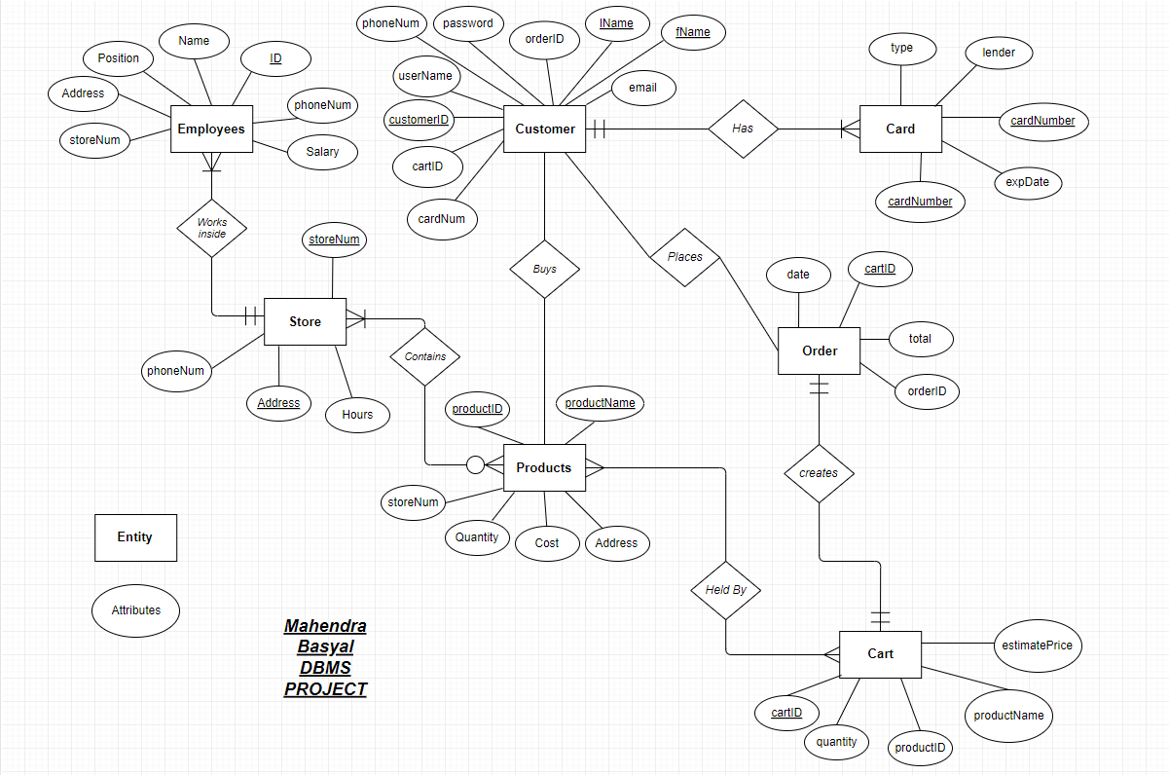

From the previous ER Diagram above there have been some changes made. From the **card entity** the duplicate attribute **cardNumber** has been replaced by **customerID.** In the entity **cart estimate price** and **productName** attribute is deleted, because we can get that information from **order entity** and **productID** attribute. When creating 3NF tables through normalization, there were two sub-tables created and they can be found in the list of entities and attributes below.

**Customer Entity**

* customerID
* fName
* lName
* phoneNum
* userName
* password
* email

|  |
| --- |
| **Type** |
| **type**  lender |

|  |
| --- |
| **Card** |
| **cardNumber**  expDate  type (FK)  customerID (FK) |

|  |
| --- |
| **Order** |
| **OrderID**  total  date  cartID (FK) |

|  |
| --- |
| **Cart** |
| **cartID**  productID (FK)  Quantity  customerID (FK) |

|  |
| --- |
| **Customer** |
| **customerID**  fName  lName  phoneNum  username  password  email |

|  |
| --- |
| **Products** |
| **productID**  productName (CK)  Cost  Quantity  storeNum (FK) |

|  |
| --- |
| **Store** |
| **storeNum**  address (CK)  phoneNum  Hours |

**(2) Relational Model:**

|  |
| --- |
| **Employee** |
| **ID**  Name  phoneNum  Position  Salary  storeNum (FK) |

**Order Entity**

* orderID
* cartID
* date
* total

**Cart Entity**

* cartID
* productID
* quantity
* customerID

**Type SubEntity**

* type
* lender

**Card Entity**

* cardNumber
* customerID
* type
* expDate

**Products Entity**

* productID
* productName
* Cost
* Quantity
* storeNum

**Store Entity**

* storeNum
* Address
* phoneNum
* Hours

**Employee Entity**

* ID
* Name
* phoneNum
* Position
* Salary
* storeNum

|  |  |  |  |  |  |
| --- | --- | --- | --- | --- | --- |
| **ID** | **Name** | **phoneNum** | **Position** | **Salary** | **storeNum** |
| **EMP001** | **Trina** | **6736696465** | **Manager** | **40000** | **B001** |
| **EMP002** | **Truman** | **4306954919** | **Employee** | **25000** | **B002** |
| **EMP003** | **Winston** | **7243836017** | **Employee** | **22000** | **B002** |
| **EMP004** | **Nyla** | **9226942422** | **Manager** | **35000** | **B001** |
| **EMP005** | **Sidney** | **9937793953** | **Employee** | **25000** | **B003** |
| **EMP006** | **Buster** | **6423145025** | **Employee** | **20000** | **B001** |
| **EMP007** | **Jaimee** | **5626843044** | **Employee** | **18000** | **B001** |
| **EMP008** | **Raleigh** | **7773922935** | **Employee** | **25000** | **B003** |
| **EMP009** | **Britni** | **9567629738** | **Manager** | **42000** | **B003** |
| **EMP010** | **Susie** | **3836730300** | **Employee** | **23000** | **B002** |
| **EMP011** | **Maris** | **7454871537** | **Employee** | **22000** | **B001** |
| **EMP012** | **Magen** | **2747027931** | **Manager** | **40000** | **B002** |
| **EMP013** | **Jim** | **5258099169** | **Manager** | **38000** | **B003** |
| **EMP014** | **Dwight** | **4786561638** | **Employee** | **20000** | **B003** |
| **EMP015** | **Michael** | **6959812356** | **Manager** | **45000** | **B002** |

**(3) Normalization**

**Store Table**

Stores branch address of store, phone no. and operating hours.

**Employee Table**

Contains Employee information from all stores.

|  |  |  |  |
| --- | --- | --- | --- |
| **storeNum** | **Address** | **phoneNum** | **Hours** |
| **B001** | **9846 Philmont St.** | **5464598893** | **7:00 AM – 9:00 PM** |
| **B002** | **7082 Sunset St.** | **6688859349** | **8:00 AM – 9:00 PM** |
| **B003** | **841 Oak Drive** | **6813660053** | **9:00 AM – 9:00 PM** |

**Products Table**

Stores product ID, product name, product cost, available quantity and the storeNum of the location where the product is available.

|  |  |  |  |  |
| --- | --- | --- | --- | --- |
| **productID** | **productName** | **Cost** | **Quantity** | **storeNum** |
| **LQL001** | **Surface Laptop 2** | **999** | **10** | **B001** |
| **CBA441** | **Asus Laptop** | **200** | **15** | **B002** |
| **CFD013** | **HP Laptop** | **450** | **12** | **B003** |
| **AWR175** | **Alienware Laptop** | **1900** | **8** | **B001** |
| **CTU008** | **Lenevo Yoga** | **830** | **10** | **B003** |
| **CBI420** | **Asus VivoBook** | **530** | **20** | **B002** |
| **NPX940** | **Samsung Notebook 9** | **1250** | **15** | **B001** |
| **FXB705** | **Asus TUF** | **1400** | **12** | **B002** |
| **MAD113** | **HP Pavilion** | **400** | **25** | **B003** |
| **LWL340** | **Lenevo Laptop** | **500** | **22** | **B003** |
| **RZS027** | **Razer Blade** | **1800** | **6** | **B002** |
| **CBD012** | **HP Stream** | **250** | **30** | **B001** |
| **GSS006** | **MSI Gaming** | **2000** | **7** | **B003** |
| **ANG515** | **Acer Nitro** | **800** | **16** | **B002** |

|  |  |  |  |  |  |  |
| --- | --- | --- | --- | --- | --- | --- |
| **CustomerID** | **fName** | **lName** | **phoneNum** | **userName** | **password** | **email** |
| **CUS541** | **Wilber** | **Wetzel** | **6607003698** | **Wil98** | **Wet66** | **wilberw@gmail.com** |
| **CUS542** | **Simonne** | **Saxon** | **9396490187** | **Sim87** | **Sax93** | **simonnes@yahoo.com** |
| **CUS641** | **Suzy** | **Sinkler** | **2469265717** | **Suz17** | **Sin24** | **suzys@hotmail.com** |
| **CUS123** | **Marco** | **Maclin** | **3103776308** | **Mar08** | **Mac31** | **marcom@hotmail.com** |
| **CUS512** | **Post** | **Malone** | **8145244478** | **Pos78** | **Mal81** | **postm@gmail.com** |
| **CUS614** | **Corrie** | **Coutts** | **6726501259** | **Cor59** | **Cou67** | **corriec@gmail.com** |
| **CUS221** | **Travis** | **Scott** | **7723477481** | **Tra81** | **Sco77** | **traviss@yahoo.com** |
| **CUS005** | **Kevin** | **Hart** | **6439532806** | **Kev06** | **Har64** | **kevinh@outlook.com** |
| **CUS111** | **Kevin** | **Malone** | **5173567219** | **Kev19** | **Mal51** | **kevinm@gmail.com** |
| **CUS420** | **Ryan** | **Howard** | **8878519554** | **Rya54** | **How88** | **ryanh@outlook.com** |

**Customer Table (Above)**

Customer Table contains customerID, first and last name, customer phone number, username, password and their email.

**Card Table**

Stores customer card information, card type, card expiry date along with customer ID.

|  |  |  |  |
| --- | --- | --- | --- |
| **cardNumber** | **type** | **expDate** | **CustomerID** |
| **4485223461219382** | **VISA** | **04/22** | **CUS541** |
| **4485557904113573** | **VISA** | **07/19** | **CUS542** |
| **5400537628441962** | **MasterCard** | **12/21** | **CUS641** |
| **5343269404454064** | **MasterCard** | **10/19** | **CUS123** |
| **4916155895069075** | **VISA** | **09/23** | **CUS512** |
| **5496165117462490** | **MasterCard** | **08/19** | **CUS614** |
| **6011707261127702** | **Discover** | **07/20** | **CUS221** |
| **6011221405560687** | **Discover** | **02/21** | **CUS005** |
| **4539225846964976** | **VISA** | **02/20** | **CUS111** |
| **6011690590713402** | **Discover** | **03/21** | **CUS420** |

**type SubTable**

Stores lender Information according to card type.

|  |  |
| --- | --- |
| **type** | **lender** |
| **VISA** | **Chase** |
| **MasterCard** | **Bank of America** |
| **Discover** | **Sears** |

**Cart Table**

Stores cart information, product in cart, quantity and customer ID.

|  |  |  |  |
| --- | --- | --- | --- |
| **cartID** | **productID** | **quantity** | **customerID** |
| **CRT001** | **AWR175** | **2** | **CUS111** |
| **CRT002** | **CFD013** | **5** | **CUS512** |
| **CRT003** | **MAD113** | **4** | **CUS123** |
| **CRT004** | **FXB705** | **3** | **CUS542** |
| **CRT005** | **ANG515** | **6** | **CUS005** |
| **CRT006** | **LWL340** | **5** | **CUS641** |
| **CRT007** | **CBD012** | **8** | **CUS221** |

**Order Table**

Stores order information, date, cartID, and total cost.

|  |  |  |  |
| --- | --- | --- | --- |
| **orderID** | **date** | **cartID** | **total** |
| **4785** | **4/10/2019** | **CRT001** | **3800** |
| **6541** | **5/19/2019** | **CRT002** | **2250** |
| **1546** | **3/24/2019** | **CRT003** | **1600** |
| **9568** | **4/15/2019** | **CRT004** | **4200** |
| **2341** | **6/21/2019** | **CRT005** | **4800** |
| **6478** | **8/19/2019** | **CRT006** | **2500** |
| **2589** | **9/14/2019** | **CRT007** | **2000** |